SESSION – 1 (Ved)

Q.1) Write a short paragraph in your own words defining what a 'program' is and give one real-life example from any app you use daily (like Instagram, Zomato, or Paytm).
Ans). A program is a set of instructions written in a programming language that tells a computer or mobile device what tasks to perform. Programs help users complete different activities such as sending messages, making payments, ordering food, or sharing photos. They are designed to solve problems and make tasks easier and faster.
Example: In the Paytm app, when a user scans a QR code and makes a payment, a program processes the transaction, verifies the payment details, transfers the money securely, and displays a confirmation message. This allows users to make quick and cashless payments.

Q.2) List three popular programming languages you have heard of, and for each, mention whether it is usually compiled, interpreted, or can be both.<br><br><em><strong>Hint:</strong> Think of languages like Java, Python, and JavaScript.</em>
Ans).
Programming Language | Compiled / Interpreted
Java | Both (Java code is compiled into bytecode and then interpreted/JIT-compiled by the JVM)
Python | Usually Interpreted
Java Script | Usually Interpreted (modern engines also use Just-In-Time compilation)

Summary :
- Java – Both compiled and Interpreted.
- Python – Mainly Interpreted.
- JavaScript – Mainly Interpreted, with JIT compilation in modern browsers.
These languages are widely used for developing websites, application, software, and many other computing tasks.

Q.3) Draw a flowchart (on paper or using any online tool) for the process of booking a movie ticket on Book My Show, starting from opening the app to receiving the booking confirmation.
Ans).
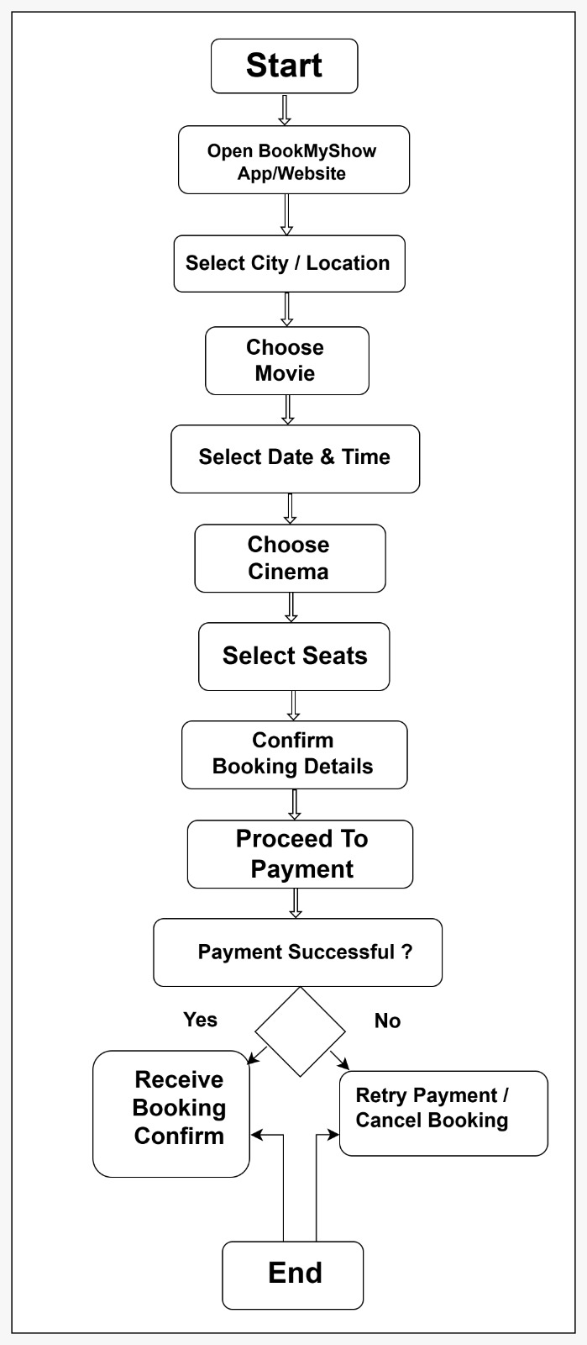

Q.4) Write down the steps (as an algorithm, using simple numbered instructions) for ordering food on Swiggy — from opening the app to completing payment.
Ans). Algorithm: Ordering Food on Swiggy
- Start.
- Open the Swiggy app on your mobile phone.
- Log in to your account (if not already logged in).
- Enter or confirm your delivery address.
- Search for a restaurant or food item.
- Select the desired restaurant.
- Browse the menu and choose the food items you want.
- Add the selected items to the cart.
- Review the items in the cart.
- Modify the quantity or remove items if required.
- Click on Proceed to Checkout.
- Verify the delivery address.
- Apply any available coupon or discount code (optional).
- Select a payment method (UPI, card, wallet, net banking, or cash on delivery).
- Complete the payment process.
- Receive the order confirmation message.
- End.
Input: Food items selected by the user.
Output: Food order successfully placed and payment completed.

